**SPRINT 1: Command line - Primer**

Activities

# STRETCH

## **Remove or copy a directory**

**Remove a directory (devacademy1)**

**Command**: rmdir devacademy1  
**Output**: output displays that when executing the terminal command rmdir devacademy1 the output process displays as indicated in the image below.

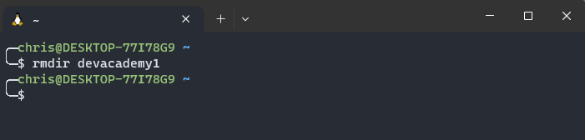

**Check to see if command executed successfully**

**Command**: dir   
**Output**: output of the dir command allows us to view directories within the current directory that you are working in. the rmdir devacademy1 command successfully removed the directory devacademy1

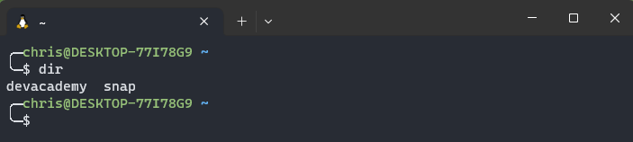

**Copy a directory**

To be able to copy a directory we need to know what directories are in the current directory we are working in by using the dir command

**Command**: dir

**Output**: command executed displays devacademy and snap directories. We are going to copy the devacademy directory

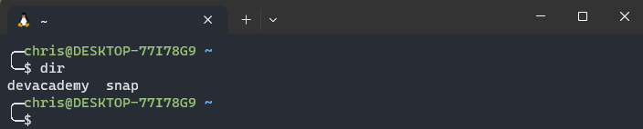

**Command**: cp -r devacademy devacademy1

**Output**: devacademy1 directory copied successfully

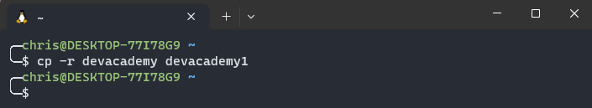

**What does the -r command mean?**

The -r command stands for recursive this command can be used with other commands e.g., cp, rm, mv etc. this command can be also applied to directories with subdirectories and files within the directory. But its good to be cautious when using this command as it permanently removes subdirectories and files within a directory if using the rm command.

**Check to see if devacademy1 directory has been copied**

**Command:** dir

**Output**: devacademy1 directory has been copied successfully

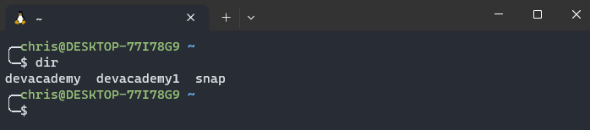

**Remove directory (devacademy1)**

**Command:** rm -r devacademy1

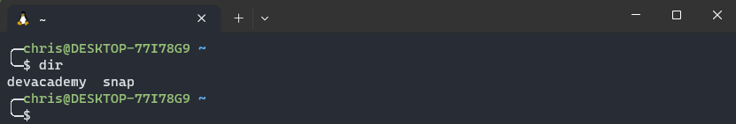**Output**: devacademy1 directory has been successfully removed

## **Find and look inside files**

**Find all files within the current directory**

**Command:** find .

**Output:** the find . command finds all files within the current directory

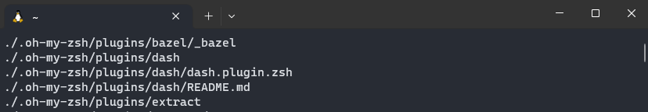

Observations

**Copying directory devacademy**

**Command**: cp devacademy devacademy1  
**Output**: output displays that -r was not specified; omitting directory ‘devacademy’. My assumptions are is that we needed to add the -r along with the cp command in order for the copy to work successfully.

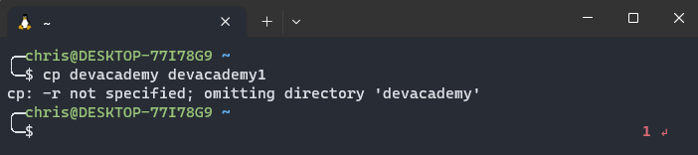

**Attempt 2**

**Command**: cp -r devacademy devacademy1

**Output**: command executed successfully



**Check to see if** cp -r devacademy devacademy1 **command successfully executed**

**Command**: dir

**Output**: devacademy1 directory created

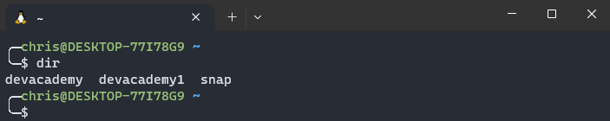

**Removing directory (devacademy1)**

**Command**: rmdir devacademy1  
**Output**: output displays failed to remove because the directory is not empty. I now understand that doing the command rmdir devacademy 1 wont work if the directory is not empty so we are going to attempt the -r command with rm command to see if it works.

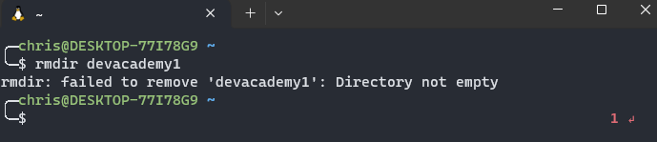

**Remove directory devacademy1 using rm -r command**

**Attempt 2**

**Command**: rm -r

**Output**: out displays a caution message asking to remove directory as indicated below. At the end of the question mark type the y key. Y stands for yes to confirm the removal of the subdirectories within the devacademy directory

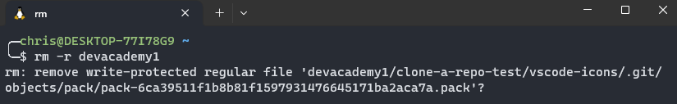

After acknowledging the caution messages to remove subdirectories and files within the devacademy1 directory command prompt goes back to the home position assuming it has removed the devacademy1 directory.

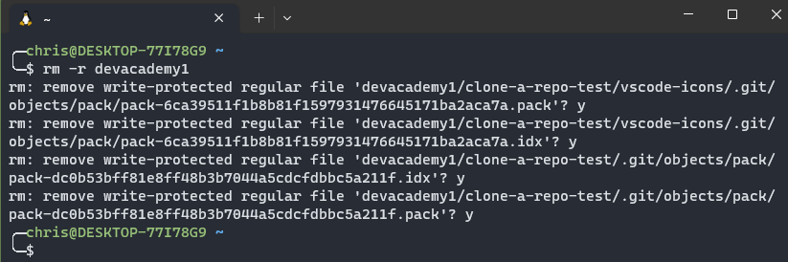

**Check to see if devacademy1 directory has been removed**

**Command**: dir

**Output**: devacademy1 directory successfully removed



Find

**Command**: find . -name ‘md’  
**Output**: command unsuccessful as I did not find any files with the letters md inside it

